**Math 120  
1.2 Basics of Functions and Their Graphs**

# Objectives:

1. Find the domain and range of a relation.

2. Determine whether a relation is a function.

3. Determine whether an equation represents a function.

4. Evaluate a function.

5. Graph functions by plotting points.

6. Use the vertical line test to identify functions.

7. Obtain information about a function from its graph.

8. Identify the domain and the range of a function from its graph.

9. Identify the intercepts from a function’s graph.

We begin this class with learning some fundamentals about functions and their graphs. **This whole class is about different types of functions and how we can use functions to model real world situations!** Let’s start by looking at the application problem on the last page of your Study Guide – our lesson today will prepare you to answer these types of questions about functions.

# Topic #1: Introduction to Relations and Functions

**Relations:**

*Example #1 -* Consider the set of 5 ordered pairs for the following relation:

This is a relation since each ordered pair relates an value with a corresponding value.

The **_____________** is the set of the -values:

The **_____________** is the set of the -values:

Functions: A function is a special relation where each number in the **_________** (the x-values) corresponds to ***________________*** number in the **____________** (the y-values). In other words, a relation is a **function** if _______________________________________

*Example #1 continued* -

Is this a function?

*Example #2* - Is this a function?

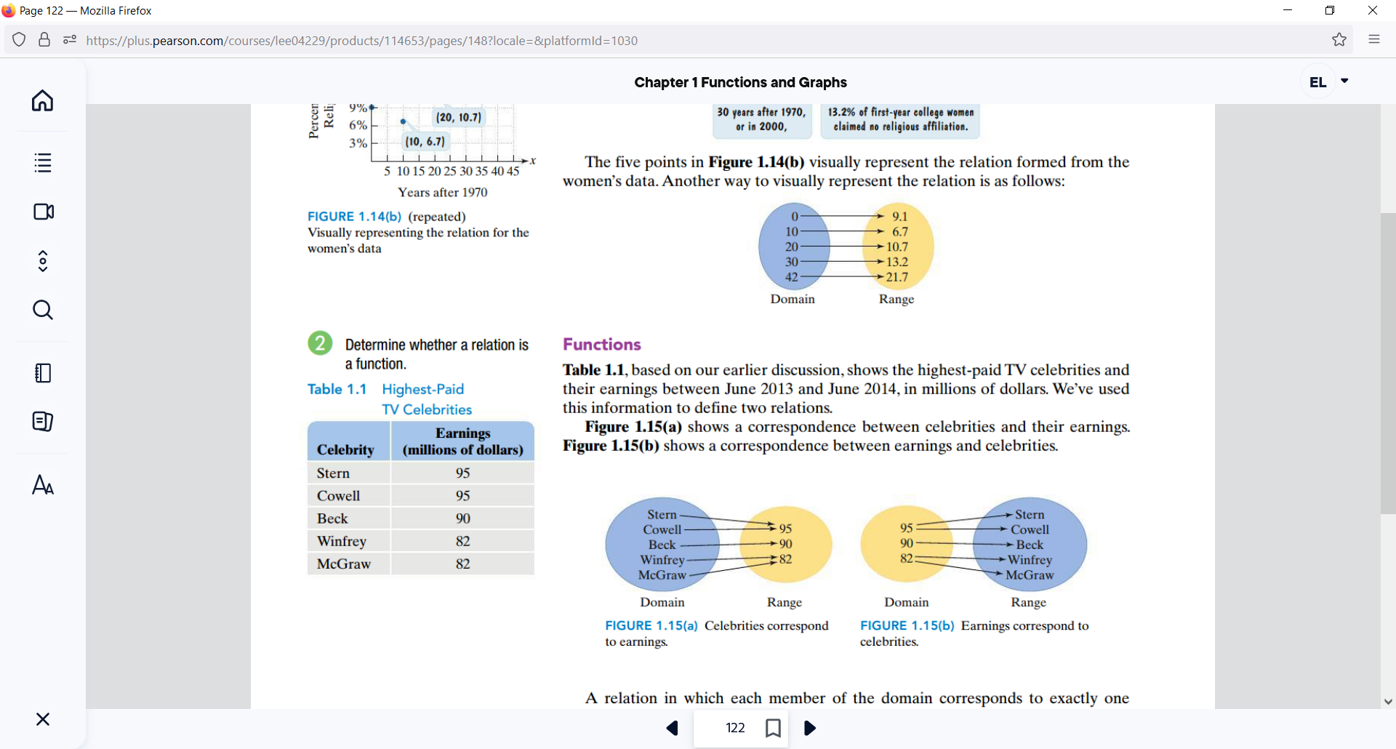

*YOU TRY #1*:

Determine if the Relation is a Function, explain why or why not and state the Domain and Range in either case.

c) {(0, 2), (-1, 1), (2, 0), (-1, 2)}

# Topic #2: Functions as Equations

Functions are normally expressed as an equation where…

is the **______________________________________**

and is the **_____________________________**

An equation is a **function** if…

To determine if an equation represents a function,

**_________________________________________**

* If **____________**, then is not a function of .
* If **____________________________**, then is a function of (more on this statement soon).

*Example 1* - Determine if the Equation is a Function

*YOU TRY #2:* 3x + y = 10

# Topic #3: The Vertical Line Test (abbreviated as VLT)

A function exists when the elements of the domain (x-values) _________________________ Not all equations are functions, but they all have a graph that shows the relationship geometrically.

Consider the graph of the equations: and

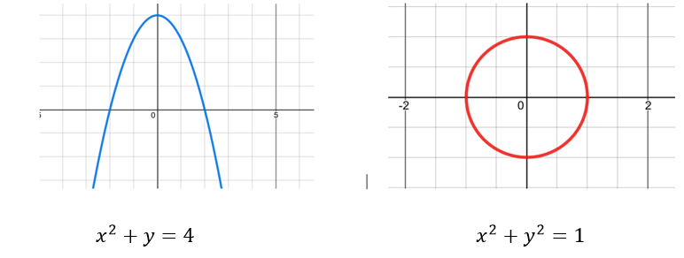

From a graphical standpoint, the graph on the left**…**

From a graphical standpoint, the graph on the right**…**

*YOU TRY #4* -Use the VLT to determine if each of the graphs below is or is not a function.

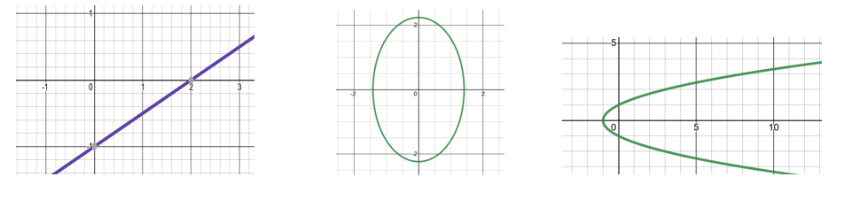

# Topic #4: Function Notation

For example, suppose

*YOU TRY #3* – Evaluate the Function

Consider the function use to evaluate:

# Topic #5: Graphs of Functions

The graph of a function is the set of its ordered pairs (that satisfy the equation) plotted on the coordinate plane system.

Consider the functions: and

USE A GRAPHING CALCULATOR TO PLOT. Both have ordered pairs that satisfy the equations and both functions have a graph:

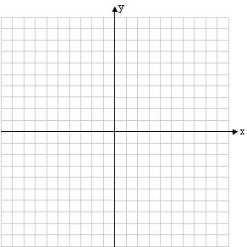

Although we could generate graphs and tables by hand, it is more efficient to use technology.

The graph and table tell us the same information and we can evaluate a function with both. For example:

# Topic #6: Analyzing the Graph of a Function

REMINDER:

Set builder notation and Interval Notation

|  | Set Builder Notation | Interval Notation |
| --- | --- | --- |
|  |  |  |
|  |  |  |
|  |  |  |

The graph of a function shows its characteristics. Here are two main features:

***(1) Domain and Range***

Recall the domain represent all _______________ for the function and the range represents all ________________

*Example #1* - Find the domain and range using the graph.

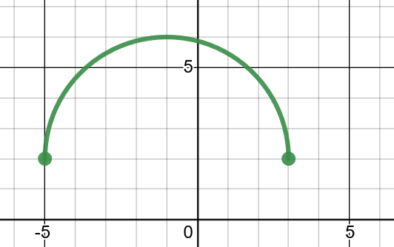

Looking from left to right (along the **x-axis**) the **domain** is all numbers between To express the values, we can write the domain as an interval

OR as a set

Looking from bottom to top (along the **y-axis**) what is the **range** of the function?

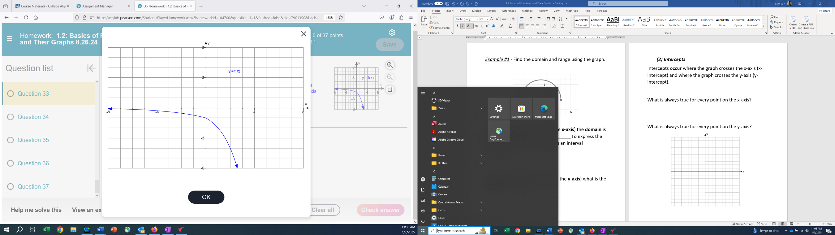*Example #2 –*

Find the Domain:

Find the Range:

***(2) Intercepts***

Intercepts occur where the graph crosses the x-axis (x-intercept) and where the graph crosses the y-axis (y-intercept).

What is always true for every point on the x-axis?

What is always true for every point on the y-axis?

*Example #3* – Find the x and y intercepts of the graph.

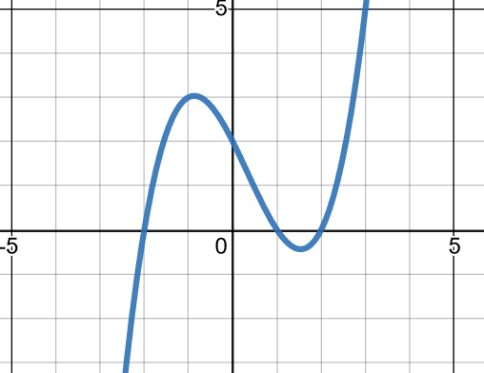

The graph crosses the x-axis three times. This graph shows that the x-intercepts are at .

The graph crosses the y-axis one time. **What is the y-intercept?**

*Example #4 –*

If the​ x-intercepts of a function are 9 and -8, then f(9)=_______ f(-8) equals_______

The​ x-intercepts, 9 and -8,

are called the​ _____________ of the function.

*Example #5 –*

Find the x-intercept and y-intercept for the following function:



*YOU TRY #5* – Analyze the Function

Use the graph of the function to answer the questions:

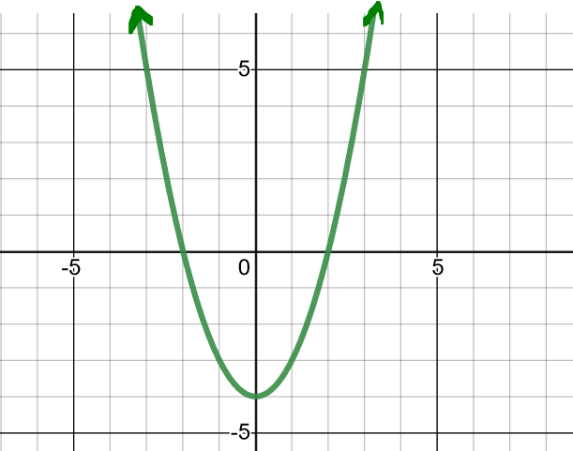

a) Find the domain and range

in interval notation and set notation.

b) Find the intercepts.

c) Evaluate

d) For what x value(s) is ?

# Topic #7: Applications of a Function – Modeling Data

Functions are often used to model the real world. The bar graph below shows the chances (as a percent) of an adult surviving to various ages after reaching 60 years old in a particular country.

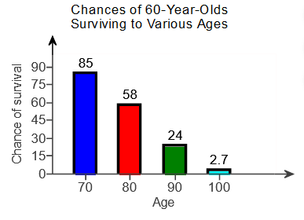

The data represents a function, where represents age (in years) and represents the chance of living to that age (as a percent). The data can be modeled with an equation, which is best done with technology.

Let x be:

Let be:

One model that fits the data shown in the graph above well is the function .

*Example #1* – Interpret the Function in Context

Use the bar graph and function model described above to answer the questions below:

1. Use the function to evaluate *g*(80) and interpret the meaning in a complete sentence.
2. Compare the value from the model to the actual value. How far off are the values?

*YOU TRY #6* - Use the function to evaluate *g*(86) and interpret its meaning.